Periodic Test IV – 2022-2023
Name: ______________________  Grade: I ______  Subject: EVS  Date: 21-12-22  Time:1 hr 45 min | Marks obtained:
 | Total:40

I. Choose the correct answer from the help box: (5 X1=5)
winter house flats harmful wind

1. Human beings live in a ______________
2. A tall building has many house are called ____________
3. We wear woollen clothes in ___________
4. Moving air is called _____________
5. Polluted air is ________________ for us.
II. Fill in the blanks with the correct answer: (5 X1=5)
6. Cotton clothes keep us ______________
a. cool b. warm c. uncomfortable d. heat

7. We should keep our house _______________
a. clean b. messy c. unclean d. untidy
8. My mother cooks food in the ______________
a. bedroom b. kitchen c. dining room d. study room
9. We can _______ air.
a. see b. feel c. move d. stop
10. We need air to _________
a. breathe b. write c. read d. paint
III. Write true or false: (5X1=5)
11. We use an umbrella in rainy season _______________
12. We wear different clothes in different season ____________
13. Shelters do not protect us from heat, cold and rain __________
14. We need air to dry our clothes ________
15. Air does not have colour, smell, taste ________
IV. Match the following: (5X1=5)
16. | Wool | a. | Disease
17. | Mop | b. | It lets in fresh air
18. | Illness | c. | To clean the floor
19. | Windows | d. | Sheep
20. | Washing machine | e. | To wash clothes
V. Answer the following: (5X2 =10)

21. How do you keep your house clean?

____________________________________________________________

22. Name any two festivals which you celebrate.

____________________________________________________________

23. Why do we wear clothes?

____________________________________________________________

24. Give examples of objects that move in air.

____________________________________________________________

25. What are the three seasons?

____________________________________________________________

VI. Complete the word web: (5X1 =5)
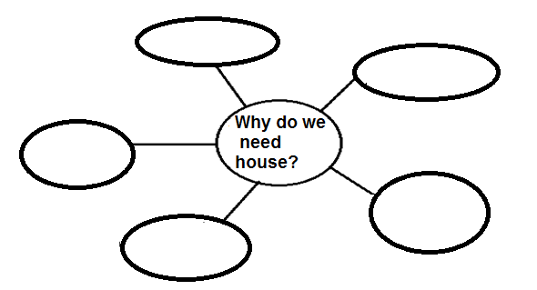

VII. Draw your house and label the parts of the house: (5X1 = 5)

